SIMATS ENGINEERING
ASSESSMENT TOOL 2: Concept Mapping

COURSE NAME: Cloud Computing and Big Data Analytics

COURSE CODE: CSA15

COURSE OUTCOME COVERED

CO1: Apply cloud computing technologies including hardware-software evolution, virtualization, web services,
and service models to develop cloud-based solutions. (BL2)

Assessment Tool Weightage: 20%

Dave’s Taxonomy: Imitation (Level 1)
Question Count: 4 Total Marks: 20

Code of Conduct
I S Jenefar (192511345) (Name / Reg No) certify that this submission is
my original work and that I have adhered to the guidelines specified for this assessment.
I understand that any violation of academic integrity rules will result in disciplinary action.

Signature of the student: ____________________

Assessment Tasks
Concept Mapping Tasks
Create concept maps for the following tasks. Each map must show key nodes, link labels, and a logical hierarchy.
1. Concept Map 1: Cloud Computing Fundamentals. Include definition, characteristics, benefits, and limitations.
2. Concept Map 2: Evolution of Cloud Computing. Connect hardware evolution, internet software evolution,
distributed systems, and service delivery.
3. Concept Map 3: Service Models. Map IaaS, PaaS, SaaS, and XaaS with provider responsibilities and user
responsibilities.
4. Concept Map 4: Virtualization and Web Services as Enablers of Cloud. Show how these two concepts support
cloud deployment and scalability.

Expected concept nodes:
• Elasticity, scalability, resource pooling, on-demand access, measured service
• Virtual machine, hypervisor, abstraction, API, SOAP, REST, provider, consumer
• Infrastructure layer, platform layer, application layer, shared responsibility

Name: S Jenefar
Reg Num: 192511345
Course Code: CSA1520
Course: Cloud Computing

CO1 AT1 CONCEPT MAPPING

CONCEPT MAP 1 : Cloud Commputing Fundamentals . Incudes Defintion , Characteristics , Benefits and Limitations

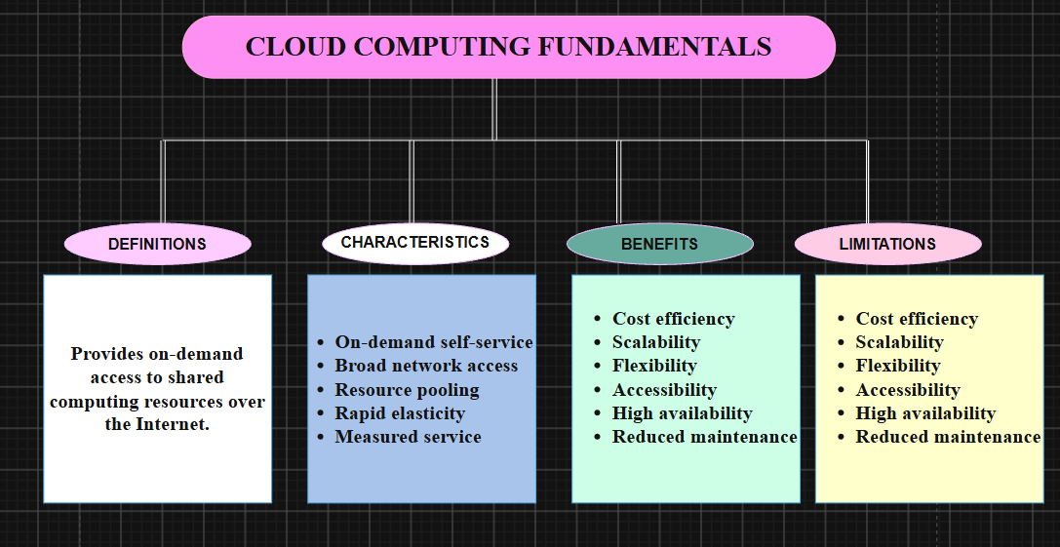

- Cloud Computing – Provides computing resources and services through the Internet.
- Definition – Explains the basic meaning and purpose of cloud computing.
- Characteristics – Describes the key features that make cloud computing flexible and efficient.
- Benefits – Shows the advantages of using cloud-based services.
- Limitations – Highlights the challenges and disadvantages of cloud computing.
CONCEPT MAP 2: Evolution of Cloud Computing. Connect hardware Evolution , Internet Software Evolution, Distributed System and Service Delivery
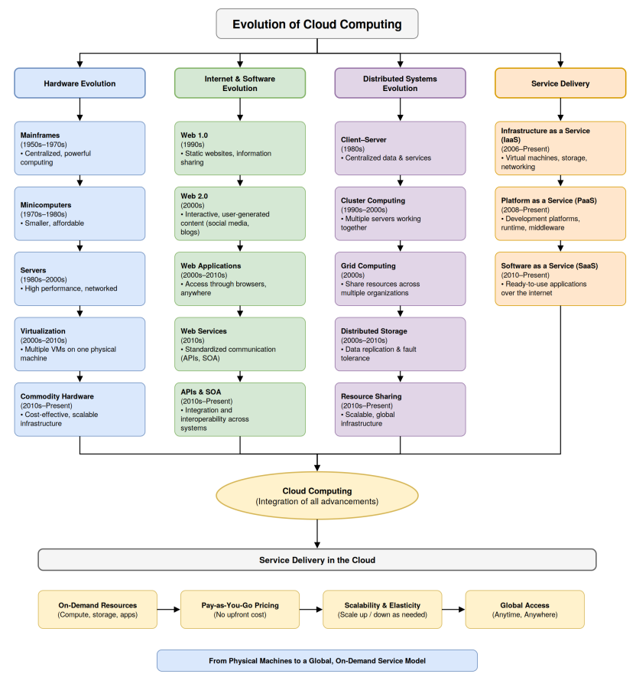
Cloud computing grew from shared computing to on-demand services:
- Mainframes (1950s-70s): Centralized machines shared by many users.
- Client-server and web (1980s-90s): Computing spread across networks.
- Cluster and grid (1990s-2000s): Machines pooled their resources.
- Virtualization (2000s): One machine ran many virtual machines.
- Web services and APIs (2000s-2010s): Software became accessible over the internet.
- Cloud services (2006-present): IaaS, PaaS and SaaS, starting with AWS.

CONCEPT MAP 3: Service Model. Map Iaas , Paas , Saas and Xaas with provide responsibilitu and user responsibility

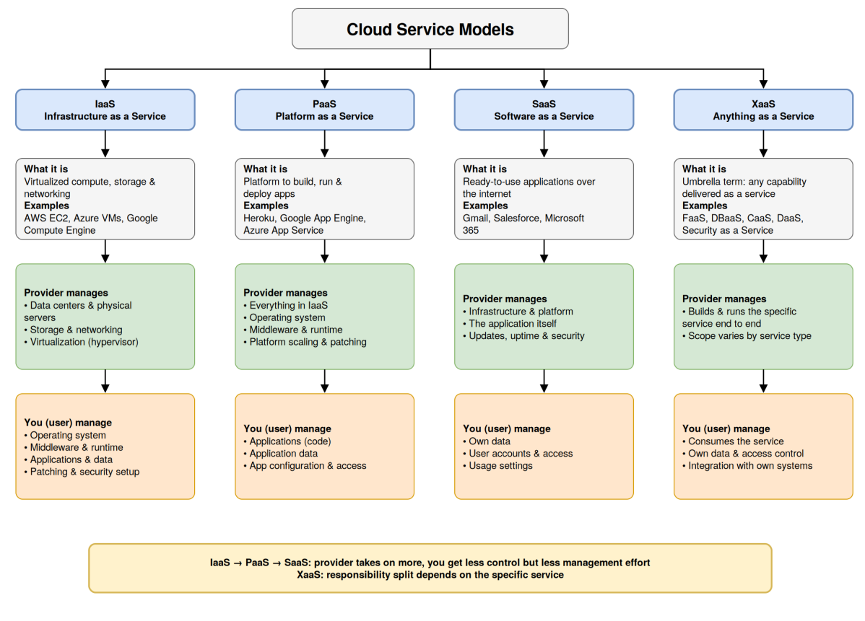

- IaaS: The provider runs the data centers, servers, storage, networking and virtualization. You manage the OS, middleware, runtime, apps and data.
- PaaS: The provider also takes over the OS, middleware and runtime. You only manage your app code, data and configuration.
- SaaS: The provider runs everything, including the application. You manage your own data, user access and settings.
- XaaS: This is an umbrella term, so the split depends on the specific service (FaaS, DBaaS and so on). The provider runs the service end to end, and you consume it and manage your data and access.

CONCEPT MAP 4: Virtualization and Web Services as enabke of Cloud. Show how does these two concept support cloud deployment and scalability

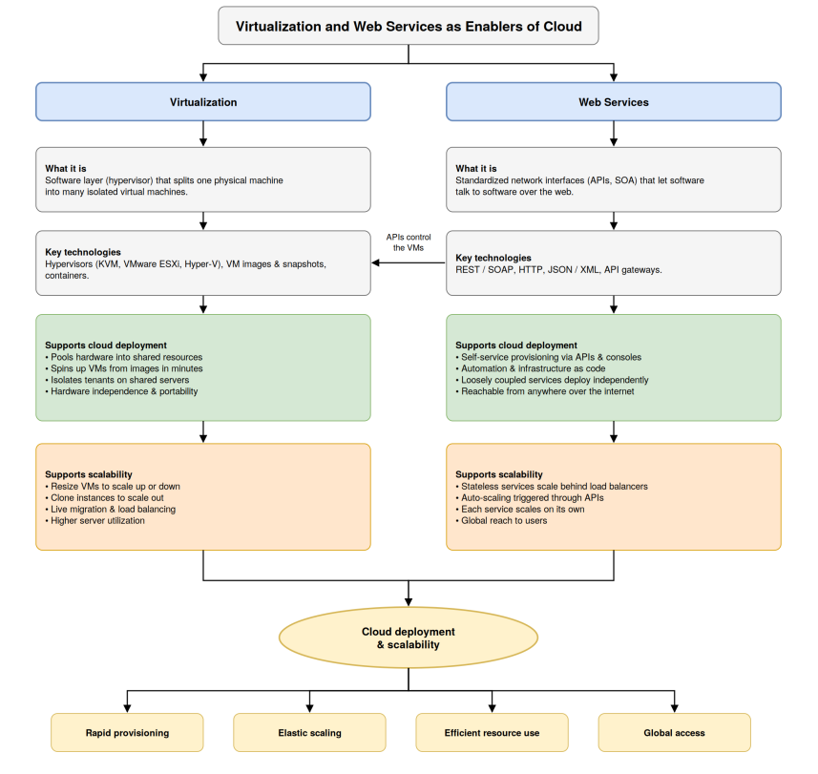
- Virtualization: A hypervisor splits one physical machine into many isolated VMs. For deployment, it pools hardware, spins up VMs from images in minutes, and isolates tenants on shared servers. For scalability, you resize or clone VMs, use live migration and load balancing, and get higher server utilization.
- Web Services: Standard APIs and SOA let software talk to software over the web. For deployment, they enable self-service provisioning, automation and infrastructure as code. For scalability, stateless services scale behind load balancers, APIs trigger auto-scaling, and each service scales on its own.
- How they connect: The arrow between the two columns shows that APIs control the VMs. Virtualization provides the flexible resources, and web services make them programmable on demand.


